**Korean Geography**

Because geography affects climate it's important to understand where Korea is and what the lay of the land is. South Korea borders North Korea to the North, faces China west across the Yellow Sea (which the Koreans call the West Sea), Japan to the east and south across the Sea of Japan (which Koreans call the East Sea

). 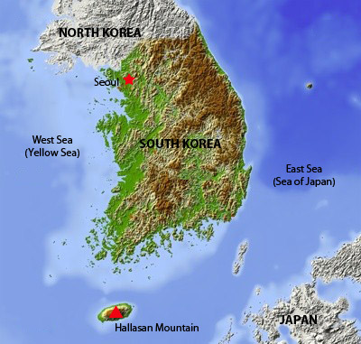

Eighty percent of the country is mountainous, and the highest peak in South Korea is Hallasan, an extinct volcano on Jeju Island that rises to a height of 1,950 meters. South Korea is only 98,477 square kilometers (38,022 square miles)- or roughly the size of the US State of Indiana, or three times the size of Vancouver Island in Canada.

With a population of 48 million people, [South Korea](http://www.footprintsrecruiting.com/teaching-jobs-in-asia/teaching-jobs-in-korea) has over 400 people per square kilometer, making it one of the most densely populated countries on earth.

[**Weather Synopsis**](http://www.footprintsrecruiting.com/weather-in-south-korea/132-weather-synopsis)

[Korea Information](http://www.footprintsrecruiting.com/component/content/section/15) - [Weather in Korea](http://www.footprintsrecruiting.com/weather-in-south-korea)

South Korea is temperate with rainfall heavier in summer than in winter. There is a wet monsoon season in the middle of the year and a dry, cold winter from November to March. During the winter, winds pick up speed and are carried from the northwest. The coldest month is January. The average winter temperature is around -5C, and begins to warm up in March.

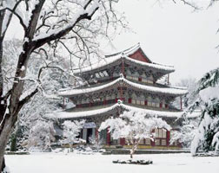

Weather from September to November is beautiful and sunny, with mild temperatures and little rain. The spring season, during April and May is also very pleasant, but more prone to rain than autumn. Temperatures will fall between 15-27C and 10-15C at night. Temperatures are cooler in the mountains.

The summer is particularly hot, muggy and prone to typhoons. The prevailing winds in the summer are southwest. The majority of typhoons usually strike from late June to September. The warmest month of the year is August. Temperatures fall between 28-37C and lows of 15-27C.

Annual precipitation is around 1500mm in the southern part of [Korea](http://www.footprintsrecruiting.com/teaching-jobs-in-asia/teaching-jobs-in-korea), and 1300mm in the central part. Precipitation during the winter accounts for less than 10% of total. More than half the annual rainfall occurs during changma season (monsoon season) when a stationary front hangs over the penninsula for about a month in the summer. Changma is the word used for the summer Asian monsoon system that starts in the southern area of Korea and proceeds northward. Changma continues for 30 days with frequent heavy rainfalls and flash floods, which can result in great national disasters. Two or three of 28 generated typhoons annually affect the penninsula from June to October. Don't leave home without your umbrella!

Humidity peaks in July to about 70-80% across the penninsula. The lowest humidity (30-40%) occurs in January and April. Humidity from September to October is pleasant, helping contribute to a healthy harvest.

Although Korea is a small country, weather across the penninsula can be quite diverse. Precipitation levels are higher in Daegu and a little lower in Seoul and Gwanju. Temperatures in Seoul are slightly lower than in Daegu and Gwanju.

[**Spring in Korea**](http://www.footprintsrecruiting.com/weather-in-south-korea/131-spring-in-korea)

[Korea Information](http://www.footprintsrecruiting.com/component/content/section/15) - [Weather in Korea](http://www.footprintsrecruiting.com/weather-in-south-korea)

Spring is one of the most beautiful seasons in Korea and several cities, including Masan, near Pusan, hold annual Cherry Blossom Festivals. 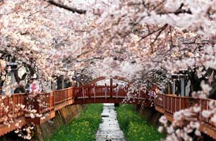

In March and April Korea experiences the ‘Yellow Dust’ phenomenon. Deforestation in central China and Mongolia causes massive amounts of particulate matter to be swept up during windstorms. Yellow Dust is usually simply an irritation- clothes and cars have to be washed more frequently than usual, however in recent years the amount of dust has become more severe, causing eye infections and respiratory ailments. The further east you are on the peninsula, the less effect this has on you. Those on the west coast take the full brunt of the Yellow Dust.

[**Winter in Korea**](http://www.footprintsrecruiting.com/weather-in-south-korea/130-winter-in-korea)

[Korea Information](http://www.footprintsrecruiting.com/component/content/section/15) - [Weather in Korea](http://www.footprintsrecruiting.com/weather-in-south-korea)

Despite the relatively small geographic footprint of Korea, they do have diverse weather around the peninsula and even on Jeju Island - the island off the southern tip of Korea.

In winter, in Seoul, the temperature hovers around freezing, and although snow occasionally falls it rarely accumulates- winter weather in [Korea](http://www.footprintsrecruiting.com/teaching-jobs-in-asia/teaching-jobs-in-korea) is similar to weather in the mid-Atlantic United States - think Washington D.C., or the Pacific Northwest minus the rain.

That said, heading directly east of Seoul to Gangwondo province, there is considerably more snow and some decent skiing.  Temperatures in Gangwondo will still hover around the zero mark but will favour slightly colder days somewhere around -2 to -8 Celsius.

Further to the south, the major centers of Daejeon and Daegu hold pretty steady around the zero mark but Busan is slightly warmer staying a couple degrees above zero and only rarely dipping into the negatives.

Jeju, the tropical island south of the Korean peninsula, is relatively warm in the coastal towns but in the north, Halla san is open to skiing in the winter time, while in the south, farmers are harvesting tangerines...

Overall, January is the coldest month in South Korea, with temperatures ranging from -5 to 5 degrees Celsius (23 – 41 degrees Fahrenheit).

[**Fall in Korea**](http://www.footprintsrecruiting.com/weather-in-south-korea/129-fall-in-korea)

[Korea Information](http://www.footprintsrecruiting.com/component/content/section/15) - [Weather in Korea](http://www.footprintsrecruiting.com/weather-in-south-korea)

Autumn is generally considered to be the most pleasant season in [Korea](http://www.footprintsrecruiting.com/teaching-jobs-in-asia/teaching-jobs-in-korea) - the leaves turn color and the weather is usually cool and sunny which makes for absolutely lovely days to check out a temple or to go for a stroll in the local park.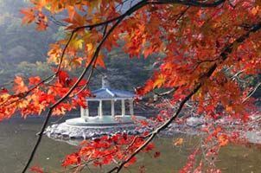

The fall is beautiful t-shirt weather. The huge colourful leaves falling on the sidewalk add lots of colour to the city. Fall is also the perfect time to go hiking. The temperature is just right, not too hot but still warm and the scenery is amazing.

Places of particular interest in the fall are Gyeonggju, Soraksan, Chirisan, Cheuncheon and Mokpo.

[**Summer in Korea**](http://www.footprintsrecruiting.com/weather-in-south-korea/128-summer-in-korea)

[Korea Information](http://www.footprintsrecruiting.com/component/content/section/15) - [Weather in Korea](http://www.footprintsrecruiting.com/weather-in-south-korea)

Summers in Korea tend to be hot and humid. The monsoon season usually starts in July and runs through August- expect brief, driving rains on an almost daily basis during these months. Cheju (Jeju) Island, off the South Coast of Korea, is the warmest and also the wettest area in South Korea.

August is the hottest month in South Korea, with average temperatures ranging from 20 to 26 degrees Celsius (68 to 78 degrees Fahrenheit). On average Pusan (Busan), the southern most major city in Korea, tends to be five degrees warmer Celsius than Seoul.

Most schools have air conditioning so your classroom isn't stifling but the subway can be intoxicating.

The mountains are absolutely spectacular at this time of year.  If you can manage a trip to Soraksan and even a morning hike up one of the local little mountains, you'll be rewarded with a fresh outlook on [Korea](http://www.footprintsrecruiting.com/teaching-jobs-in-asia/teaching-jobs-in-korea).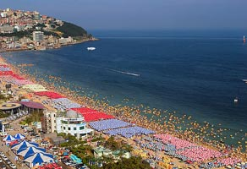

Another recommendation during summer is to hit the beach.  There are two nationally famous beaches Haeundae in Busan and Gyeongpodae in Gangneung, directly east and across the country from Seoul.  Space is an issue on these beaches in the summer which is what makes a trip here very surreal and a lot of fun for those of you who can handle a crowd.  Smiling faces and fun abound in summer.